**Singleton Design Pattern**

**Assignment - 2**

Name - Heet Dobariya Roll No. - 22BCP177 Group - G5

* **Program :** Create a Singleton Design Pattern for Packaging example.
* **UML Diagram :**

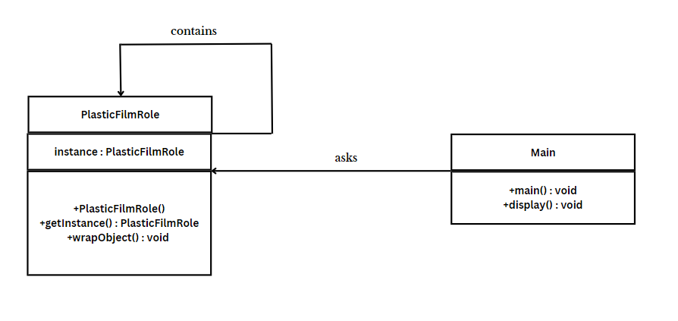

* **Code :**

public class PlasticFilmRole

{

private static PlasticFilmRole instance;

private PlasticFilmRole()

{

System.out.println("Plastic Film Role instance created.");

}

public static PlasticFilmRole getInstance()

{

// Lazy initialization: create the instance only if it doesn't exist yet

if (instance == null) {

instance = new PlasticFilmRole();

}

return instance;

}

// Method to wrap an object with plastic film

public void wrapObject(String objectName)

{

System.out.println("Wrapping " + objectName + " with plastic film.");

}

public static void main(String[] args)

{

// Get the PlasticFilmRole instance

PlasticFilmRole plasticFilmRole = PlasticFilmRole.getInstance();

// Wrap different objects using the same instance

plasticFilmRole.wrapObject("Book");

plasticFilmRole.wrapObject("Gift");

plasticFilmRole.wrapObject("Electronics");

}

}

* **Output :**

